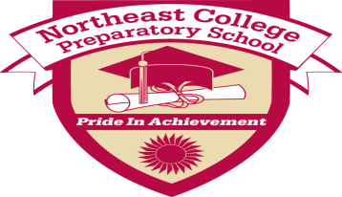
Northeast College Preparatory School Lesson Plan
Teacher(s): Mr. Holloway Grade: Middle School, 7/8
Subject(s):Technology Date of delivery: 10/22-10/29 (Classes
meet every other day)

- Common Core Learning Standards Addressed:

Writing Standards: Standard 6- Use Technology, including the internet, to produce and publish writing
and to interact and collaborate with others.
NYS Standards: Standard 5 - Technology

- Learning Target(s): (What will the students know and be able to do as a result of this lesson?)

Students will be able to know what the difference between Technology and Science is and how they relate.
Students will be able to list and describe the four major technology fields.
Students will be able to list positive and negative impacts technology has on our society.

- Essential Question(s)/Guiding Question(s):

What is Technology?

- Higher Level Thinking Questions to be used during the lesson:

What kind of impacts does technology have on our everyday life’s?

- Bridge/Connections/Hook:

Discuss with the students all the different technologies they use and what kind of impacts each technology
has on our society.

- Materials/Resources/Technology Integration:

Use of the computer!

- Mini Lesson/Process/Procedure:

Discuss with the class: what technology is, four major technologies, & impacts of technology.

- Work Time/Activities/Tasks: (What learning experiences will students engage in? How will you use these learning experiences or their student products as formative assessment opportunities?)

Students will be researching the topic and answering questions.

- Access for All: (How will you ensure that all students have access to and are able to engage appropriately in this lesson? Consider all aspects of student diversity.)

Students will be working together and will be sharing out with the class of their findings.

- Homework/Extensions/Enrichment:

N/A

- Formative Assessment Criteria for Success: (How will you and your students know if they have successfully met the outcomes? What specific criteria will be met in a successful product/process? What does success on this lesson’s outcomes look like?)

Students will be researching and answering specific questions on the topic. The teacher will review the material and grade the assignments.

- What adjustments will be made for students that do not meet the Criteria for Success?

We will review the material and students will be able to re-do their work.

Reflections:
- How does this lesson reflect academic rigor?

Students will have to research the topic and find key concepts address in the unit.

- How does this lesson engage students in collaborative learning and enhance their collaborative learning skills?

Students will be working together.

